Table of Contents

1 Superadmin Module User Manual

1.1 1. Role Objective
The Superadmin role governs system-wide configuration, user administration, compliance visibility, and strategic reporting.

1.2 2. Module List (Superadmin)
- Login
- Dashboard
- User Management
- Audit Logs
- Call Logs
- Escalation Logs
- Reports
- Staff Ratings
- Notifications
- Settings

1.3 3. Login Module
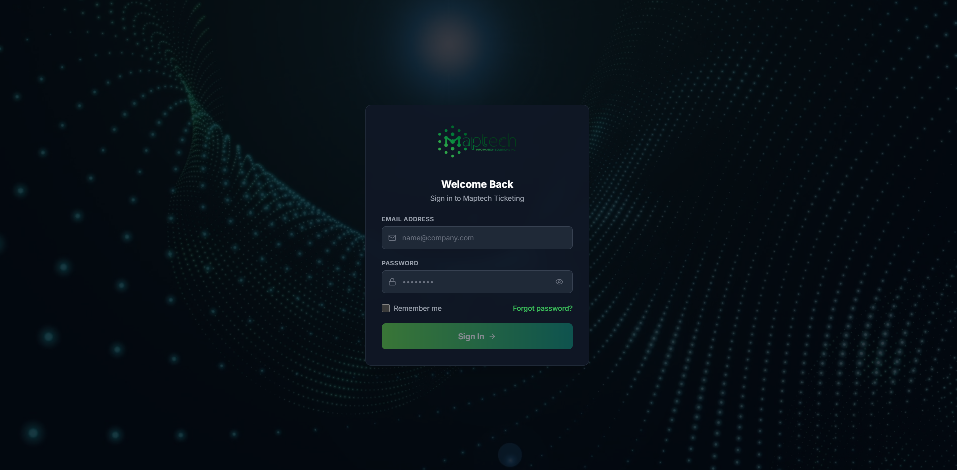
Superadmin Login
Steps: 1. Enter Superadmin credentials. 2. Click Sign In. 3. Confirm redirect to Superadmin dashboard.

1.4 4. Dashboard Module
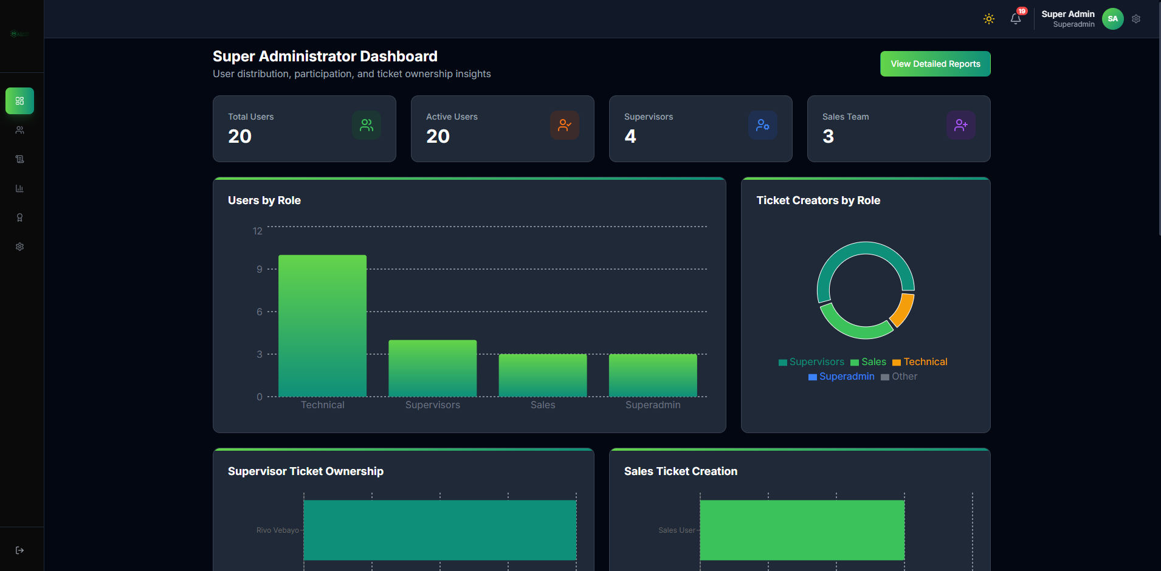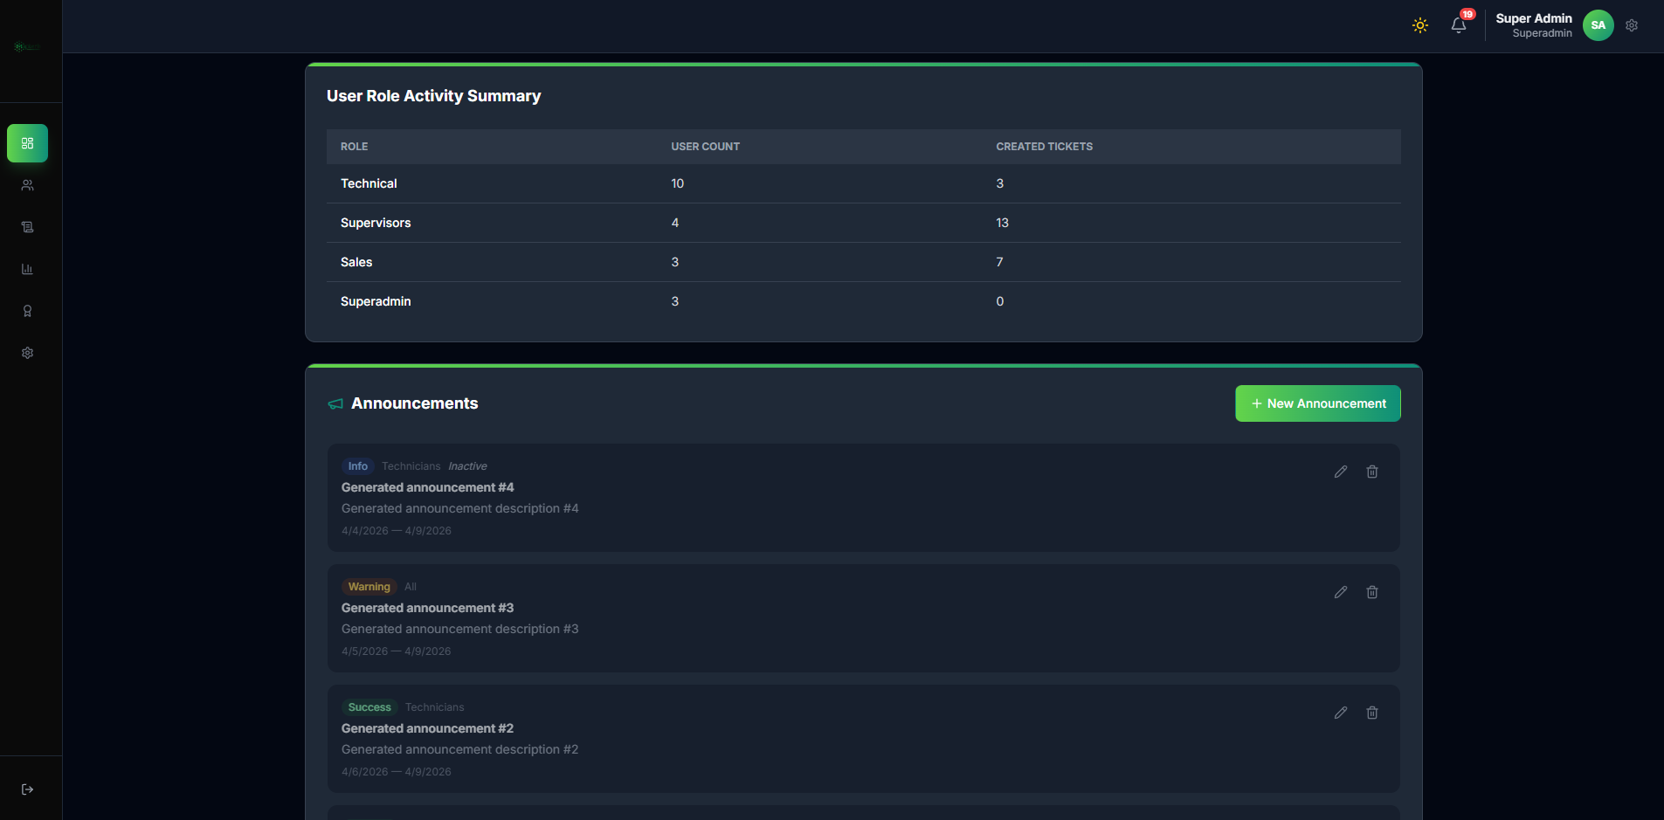
Purpose: - View system-wide user/ticket operational health. - Monitor role distribution and ownership insights. - Track organization announcements and summary cards.

1.5 5. User Management Module (Core)
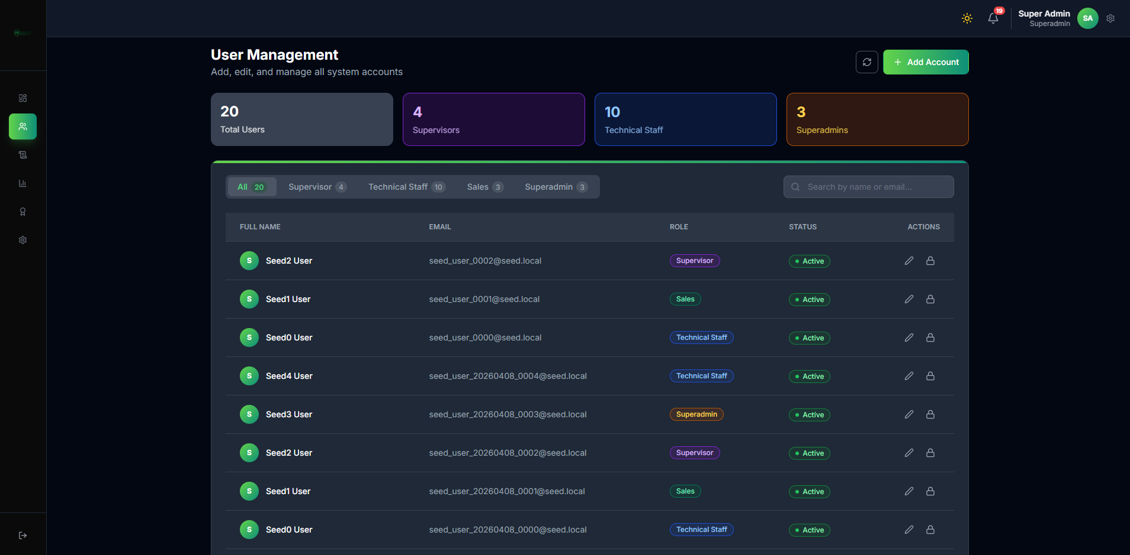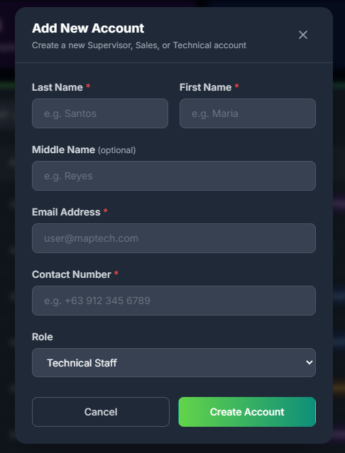
Purpose: - Create and maintain user accounts across all roles.
User Administration Steps: 1. Open User Management. 2. Review counts by role (Supervisor, Sales, Technical, Superadmin). 3. Click Add Account. 4. Enter identity details and select role. 5. Save account and confirm active status. 6. Use action controls for edit/lock/reset operations.

1.6 6. Audit Logs Module
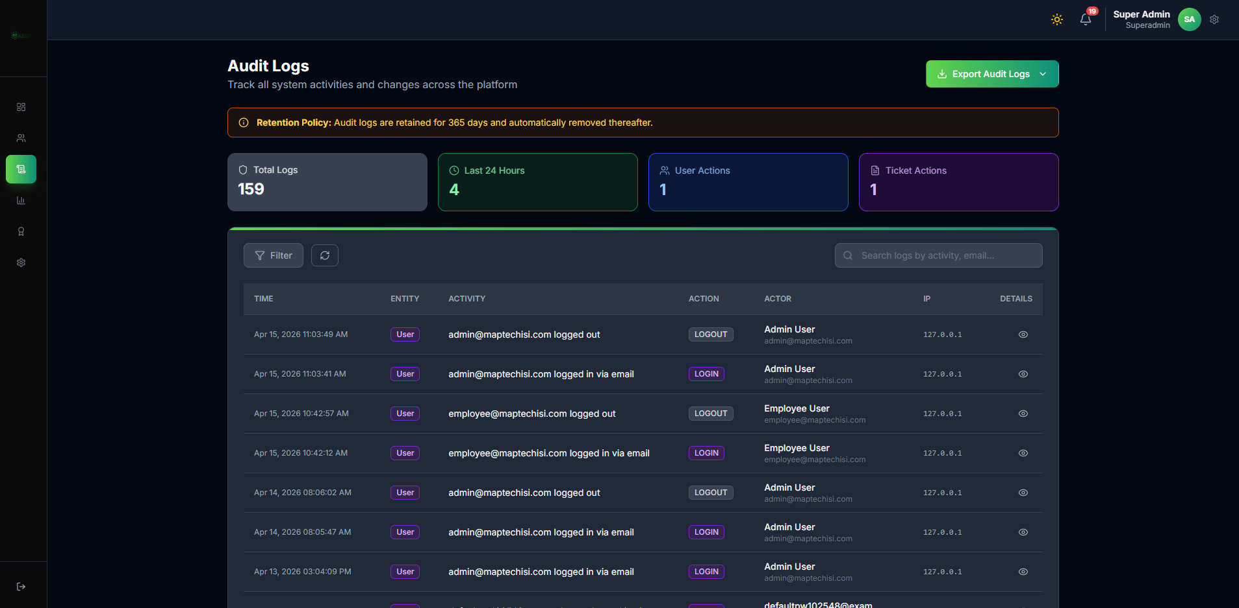
Superadmin Audit Logs
Purpose: - Investigate platform activity with highest visibility.
Steps: 1. Filter by entity, actor, action, and time. 2. Review detail records for security and compliance checks. 3. Export logs when required.

1.7 7. Call Logs Module
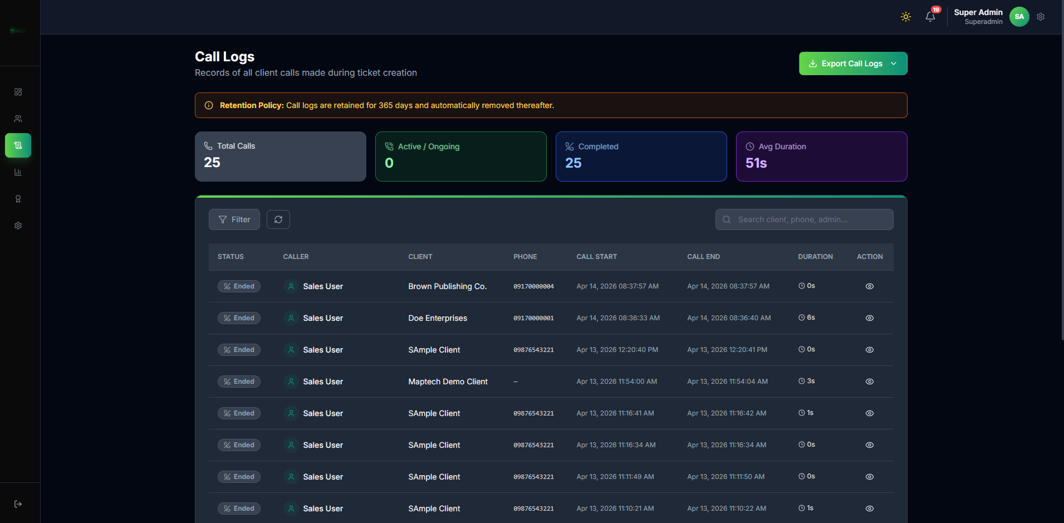
Superadmin Call Logs
Purpose: - Monitor call activity metrics and historical call traces.

1.8 8. Escalation Logs Module
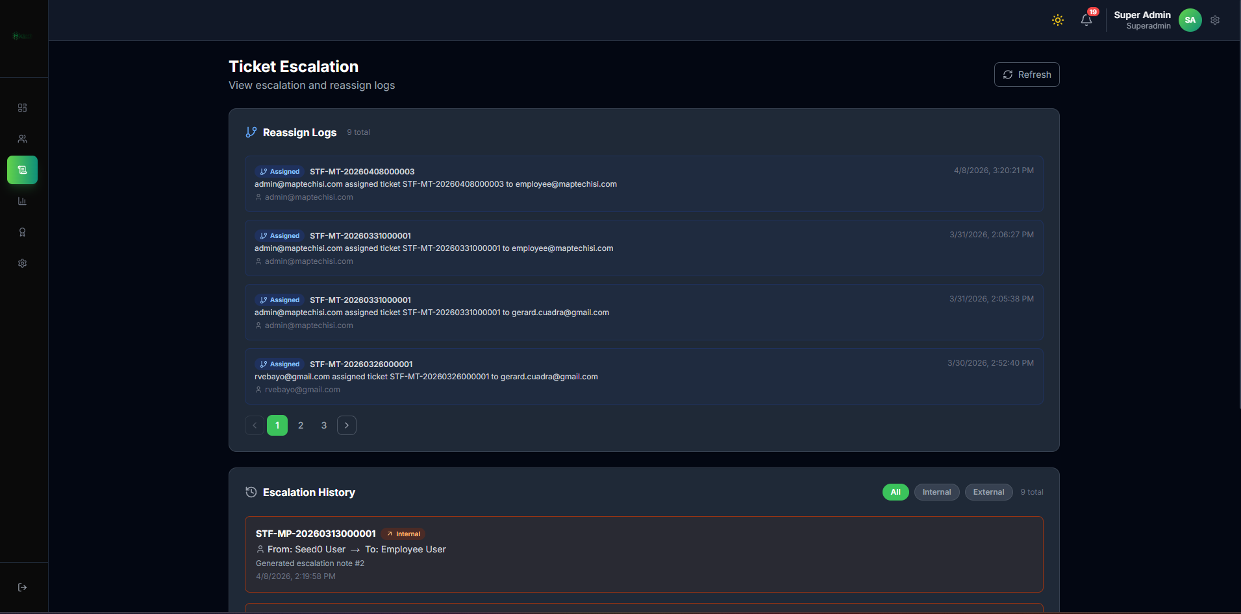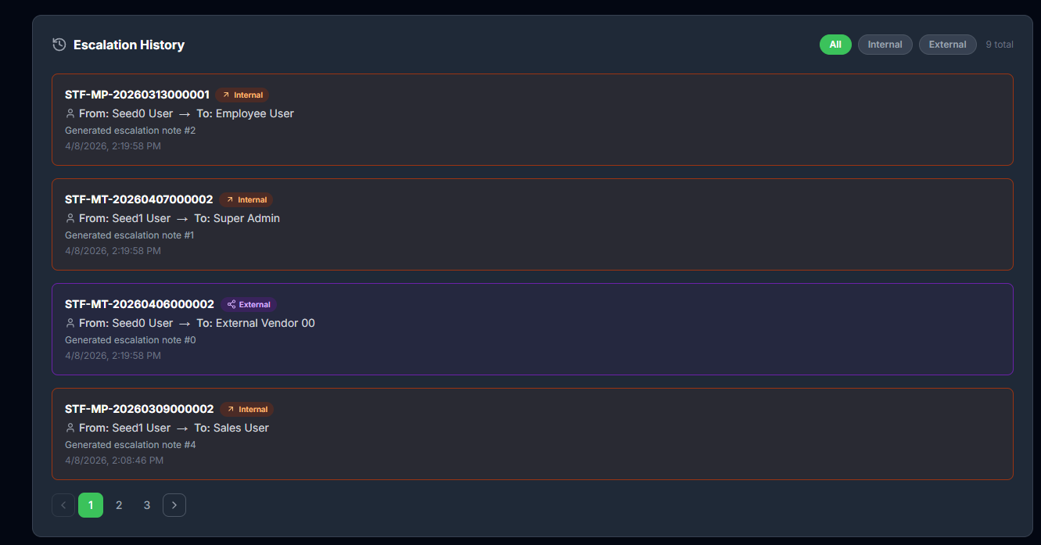
Purpose: - Observe reassignment and escalation patterns across the organization.

1.9 9. Reports Module
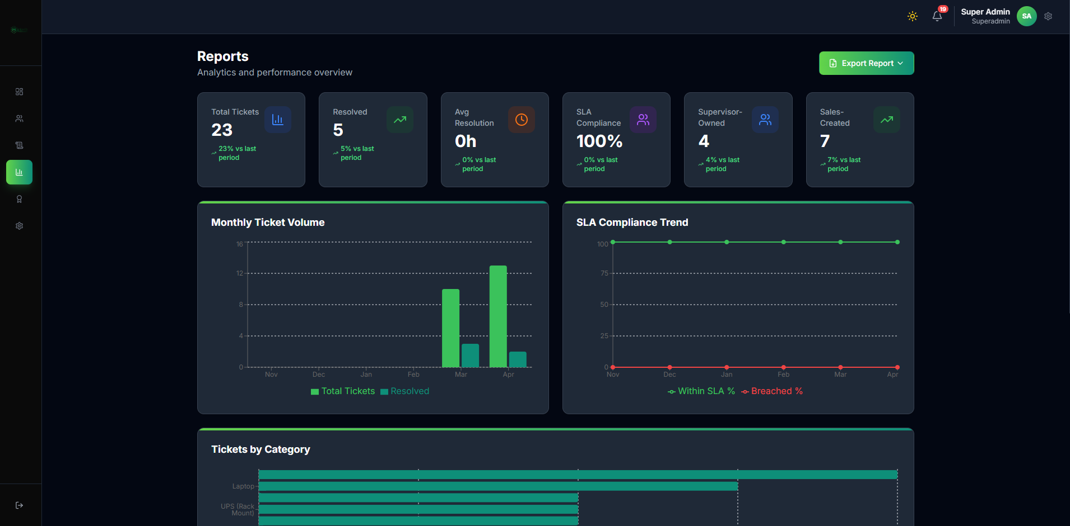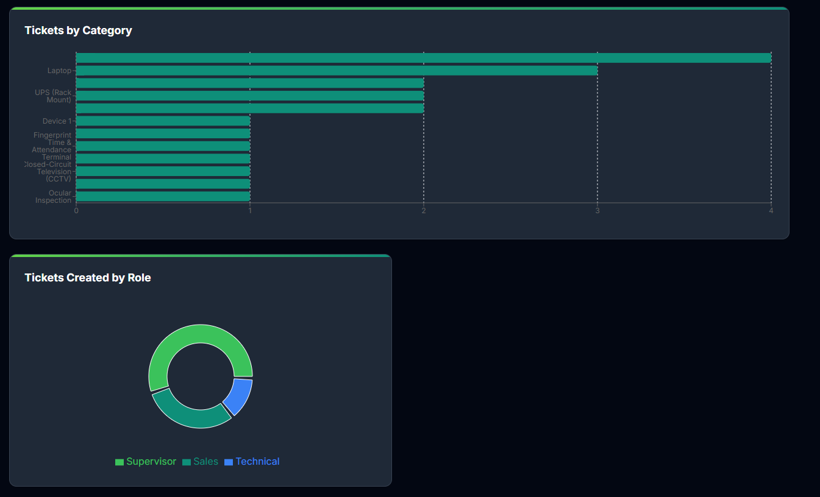
Purpose: - Analyze ticket volume, SLA compliance, category breakdown, and role output.
Report Review Checklist: 1. Check total tickets and resolved count trends. 2. Verify SLA compliance trend line. 3. Inspect ticket category distribution. 4. Review role-created ticket composition.

1.10 10. Staff Ratings Module
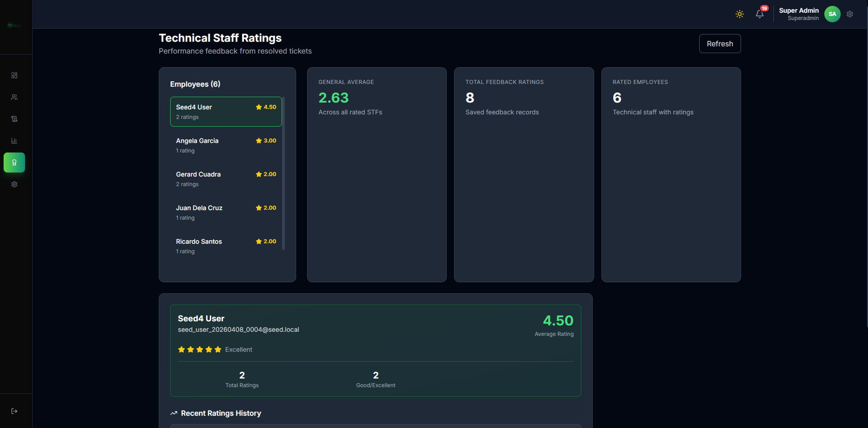
Superadmin Staff Ratings
Purpose: - Review technical performance feedback from resolved tickets.

1.11 11. Notifications Module
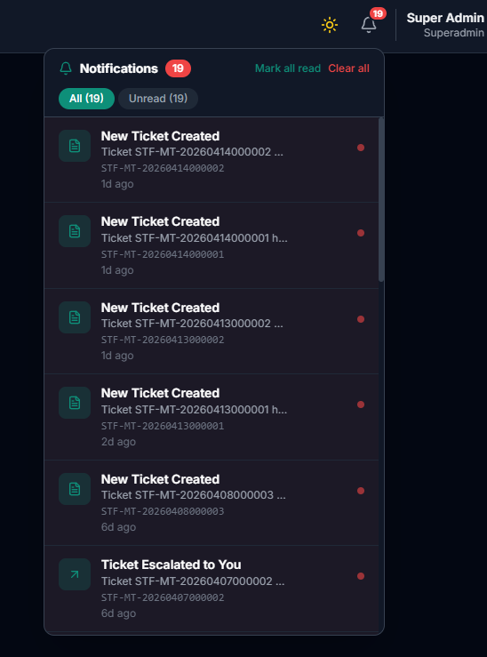
Superadmin Notifications
Purpose: - Monitor important events and unread alerts.
Usage: 1. Open bell icon panel. 2. Filter All vs Unread. 3. Mark read or clear all when reviewed.

1.12 12. Settings Module
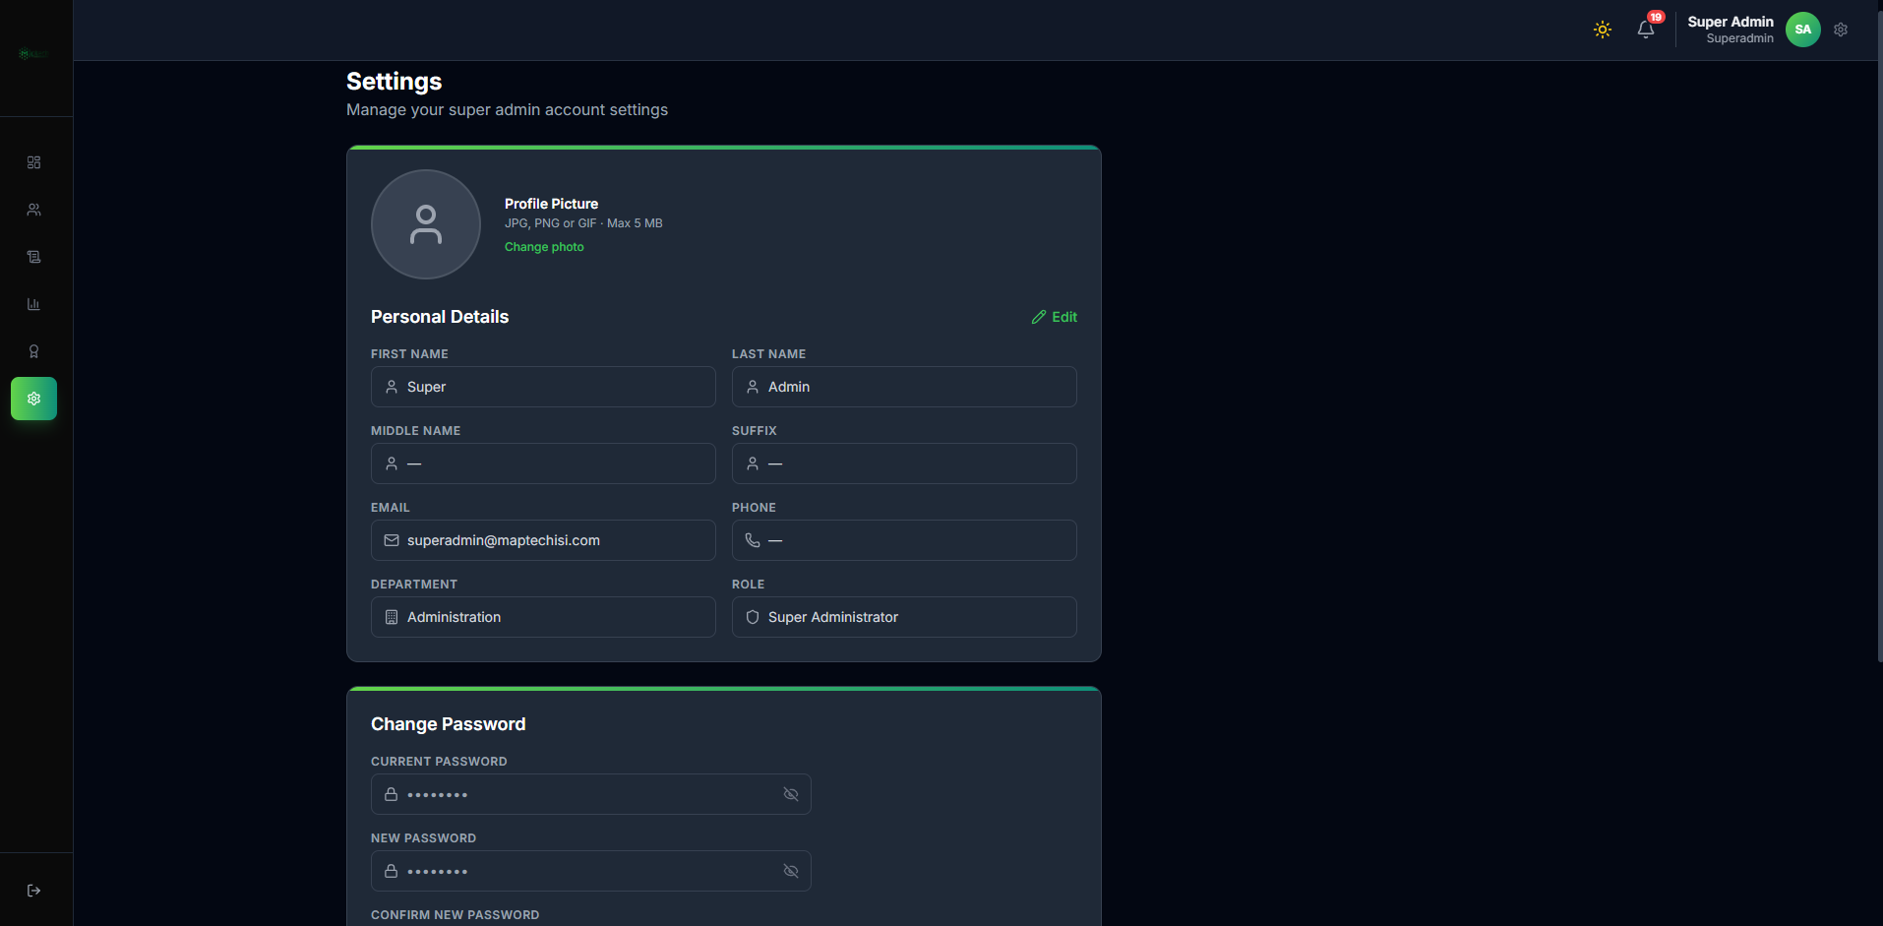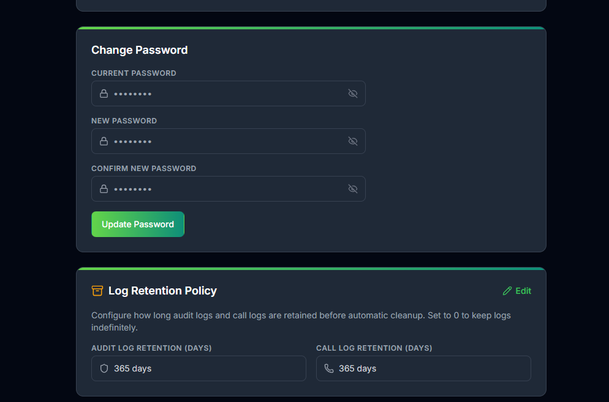
Purpose: - Manage profile/password and key system-level settings (for example retention policy controls).

1.13 13. Governance Workflow Lines
Flow Line G1: Review dashboard for system health.
Flow Line G2: Maintain user lifecycle (create/edit/activate/deactivate).
Flow Line G3: Monitor audit and escalation logs for policy compliance.
Flow Line G4: Review performance reports and staff ratings.
Flow Line G5: Adjust settings/retention policies as needed.

1.14 14. Superadmin Accuracy Controls
- Enforce correct role assignment during account creation.
- Periodically review audit trails for unusual behavior.
- Keep retention settings aligned to policy requirements.
- Use reports for corrective operational actions.

